# Problem Definition

One of the most common problems hostel students face these days is following a meal plan and maintaining a balanced diet. This is a challenge that many students face and as a result of this, they often undergo drastic physical changes in a matter of months. Often, students are unable to comprehend the nutritional value of the food that is available in the mess and end up eating unhealthily.

In lieu of this, we decided to make a smart meal planner that is flexible and caters to the individual as a college student. We take your weekly mess menu as well as your food logs and by running an AI it generates the best course of action for your day.

The available solutions for generating meal plans are based on the fact that the user is free to decide the menu of the week. Our product is customized for the mess users, giving them the much-needed assistance in planning their meals from available options.

# Technology Landscape Assessment

Meal Planning AI Softwares

* Whisk’s Culinary Coach - AI-powered nutrition platform that provides food recommendations based on flavour preferences and avoidances
* Frélii - a health tool that uses AI to build unique nutrition and health needs
* Noom – A software that takes the user's exercise and food logs

Recipe AI Softwares

* Spoonshot - AI-based app that suggests recipes based on available ingredients
* RecepiBook - uses AI to recommend food recipes based on user behavior and cravings
* Gulpie – uses AI to recommend Restaurants and places to eat, to suit the user's diet.

# Project Plan

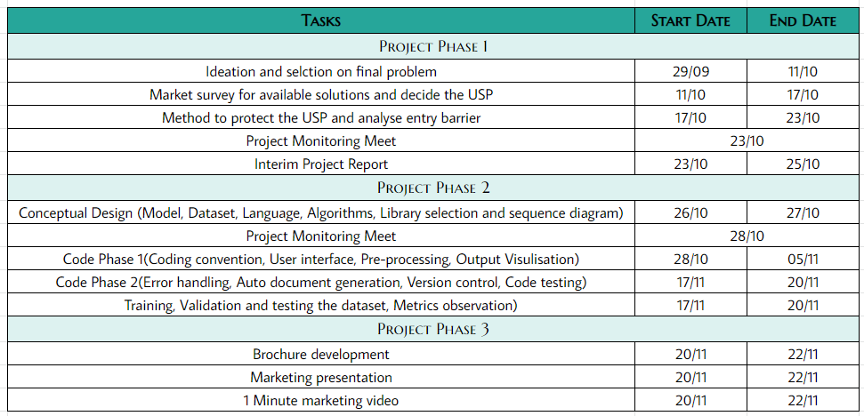

# User Interface

# 

# Output Visualization

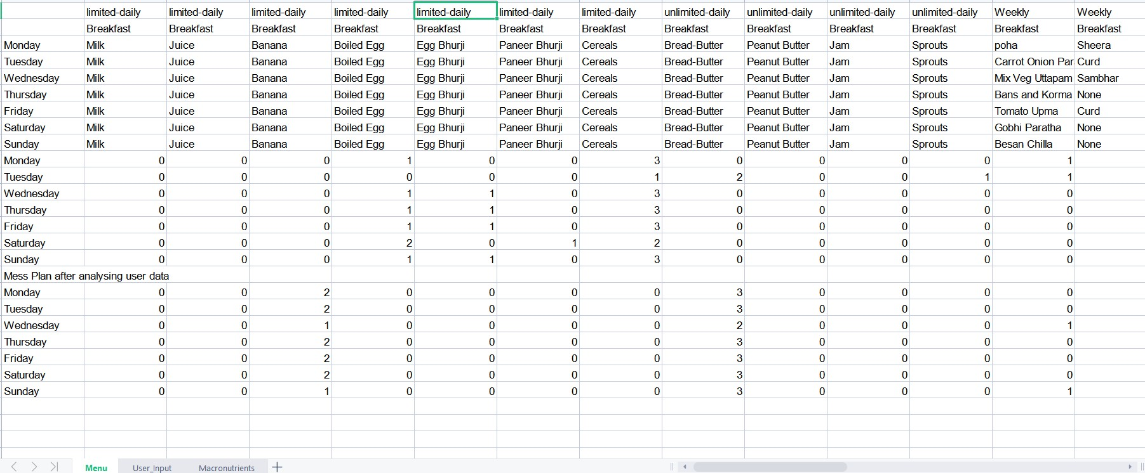

# Business Plan

We aim to first implement our product in IITB Campus by collaborating with Mess caterers and assistance of Hostel Councils.

After a significant period of implementation, feedback and improvement, we will then approach various other residential campuses in India for implementation of our product in their mess facilities.

After this we will aim the global market